Why Magnetic Resonance? The Wide-Ranging Applications of MR

The Wide-Ranging Applications of MR

Table of Contents

Expected Learning Outcomes 2

Background Information 2

Small Group Discussion 3

Brief History of Magnetic Resonance 3

Guided Inquiry Questions 4

Different MR Technologies 4

Guided Inquiry Questions 8

How does MR Compare with Related Technologies? 8

Spectroscopy 9

Imaging 11

Guided Inquiry Questions 12

Reflection Questions 12

Cited Sources 12

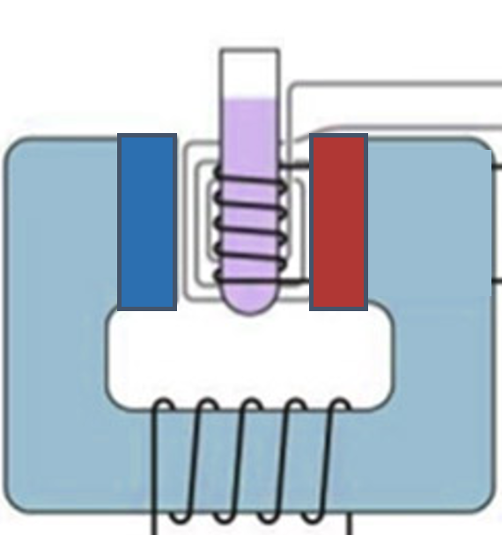

## Expected Learning Outcomes

At the end of this module, students should be able to…

1. provide different examples of modern-day technologies that use magnetic resonance techniques
2. identify the key elements of a magnetic resonance apparatus
3. specify how magnetic resonance differs from other spectroscopy and imaging modalities

**Suggested Activity:** [Energy-Level Transitions and Spectroscopy](https://docs.google.com/document/d/1sA7SVnuS5gfDFUgVnfkDIzDSpjks1m0PU_ikFs0WY3U/edit?usp=sharing)

# Background Information

**magnetic resonance** - technique that utlizes the interactions of matter and light in the presence of magnetic fields

We may not be able to directly see the quantum world of elementary particles, atoms, and molecules, but, fortunately, we *can* see how these quantum particles interact with light to uncover the strange rules of physics they appear to follow. Scientists observed that atoms emit and absorb light at certain frequencies, which led to the discovery that atoms have quantized energy levels. Scientists then learned how to use this information to identify different atoms and molecules, and develop technology that harnesses the amazing properties of the quantum world. Throughout these materials, we will explore the quantum realm through the lens of **magnetic resonance** (MR), which has found applications in a wide variety of scientific disciplines and has become a valuable research tool to uncover new quantum mysteries.

**quantum mechanical properties** - physical properties that are primarily significant at the level of atoms and molecules where the weird laws of quantum mechanics apply

**external magnetic field** - a magnetic field typically generated by a strong magnet that is located outside the sample

**nuclear magnetic resonance** - where magnetic resonance signal comes primarily from the nuclei of specific atoms

**electromagnetic radiation** - type of energy carried by electromagnetic waves (light); the frequency determines the energy range and categorization of light in the electromagnetic spectrum

MR uses the **quantum mechanical properties** of atoms inside a sample and placed in an **external magnetic field** to provide valuable information about their local magnetic environments. This information can be used to identify chemical composition and structure of a sample, as well as provide ways of manipulating quantum spins to encode information useful for biomedical imaging or even serve as [qubits](https://www.quantum-inspire.com/kbase/what-is-a-qubit/) in a [quantum computer](https://en.wikipedia.org/wiki/Quantum_computing). Across these activities, you will learn the physics behind **nuclear magnetic resonance** (NMR), as well as explore multiple specific applications. NMR uses **electromagnetic radiation** - a fancy name for the energy carried by different forms of light - to interact with nuclei in matter. By working through these activities, we hope that you may ultimately develop and demonstrate the appropriate research skills required to design, implement, and analyze NMR experiments that address novel questions. But before we get into the details, we want to provide some of the motivation behind this work.

Here we will provide a short synopsis of the historical impacts of MR research, a comparison of MR technology with other similar technologies in the modern-day scientific workforce, and reflect on the potential future of MR techniques.

## Small Group Discussion

* In your life, where else have you seen interactions of light with matter?
* Who might find it worthwhile to understand magnetic resonance techniques?

# Brief History of Magnetic Resonance

MR techniques have been developed over the course of the past century as scientists have explored and understood more of the quantum realm. These techniques have been utilized in a variety of different scientific disciplines and new techniques are still being developed, as MR provides a unique way to control quantum systems for future technologies. Below is a list of the many Nobel prizes awarded in the past century that were critical to the development and application of MR techniques(1).

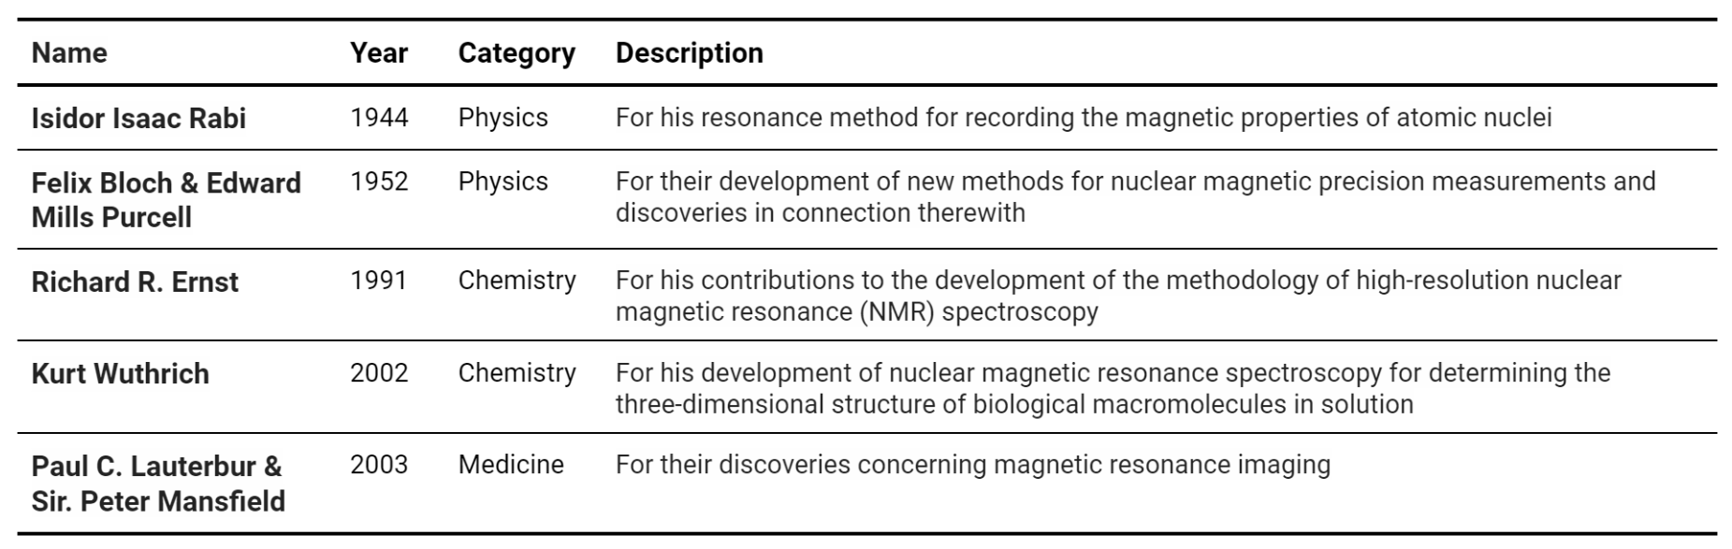

## Guided Inquiry Questions

***FURTHER STUDY:*** To learn more about the biographies of the Nobel Prize winners and their work, check out [nobelprize.org](https://www.nobelprize.org/).

1. From the information provided, do you think it is fair to say that MR impacts multiple scientific disciplines? Use evidence to make your case.
2. What voices are we missing in this brief history of magnetic resonance? Would this in any way affect its overall impact? Why or why not?

# Different MR Technologies

Magnetic resonance techniques are used in a variety of different technologies. Below we provide a brief description and simple diagram of four different apparatuses utilizing MR. They may all look very different from each other but are using the same underlying physics. Study this information to answer the guided inquiry questions below.

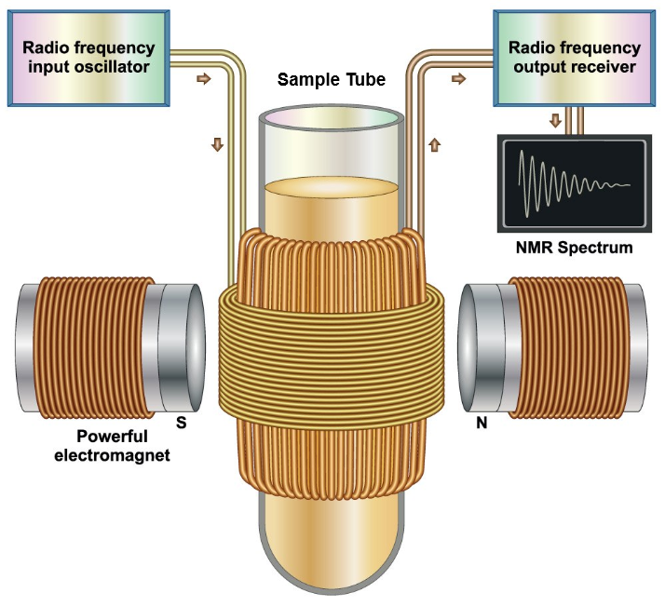

**NMR spectroscopy** - uses electromagnetic radiation in the radio frequency (RF) region to interact with nuclei within a sample placed inside a magnetic field. These RF frequencies resonate with particular nuclei and detecting the response of specific nuclei to these frequencies can provide chemical information about the sample.   
Image courtesy of Sigma-Aldrich (2).

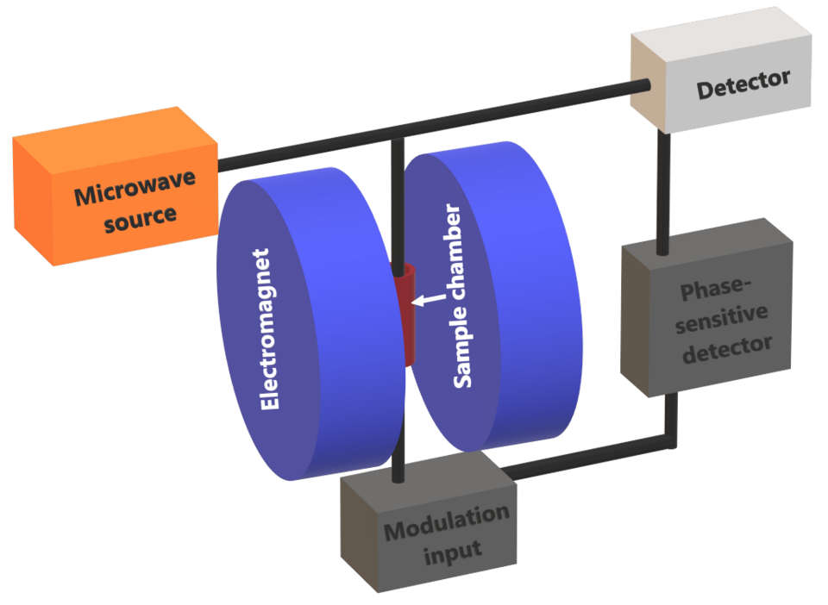

**electron spin resonance (ESR) or electron paramagnetic resonance (EPR)** - uses electromagnetic radiation in the microwave frequency region to interact with electrons within a sample placed inside a magnetic field. These microwaves resonate within a cavity where the sample is placed and the response of the electrons to these frequencies can provide chemical information about the sample.   
Image Source: 2ReinreB2, [CC BY-SA 4.0](https://creativecommons.org/licenses/by-sa/4.0/deed.en), via Wikimedia Commons (3).

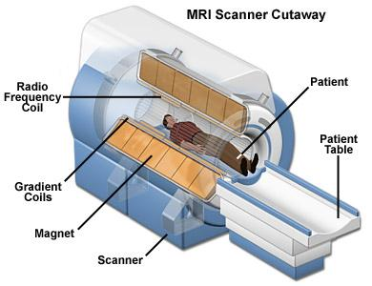

**magnetic resonance imaging (MRI)** - uses electromagnetic radiation in the RF region to interact with nuclei within a patient placed inside a large uniform field, along with magnetic field gradients that changes the magnitude of the magnetic field at different spatial positions. A non-invasive, three-dimensional spatial image can be constructed by measuring the response of specific nuclei to the applied magnetic fields.  
Image © 2025 National MagLab, Public Domain (4).

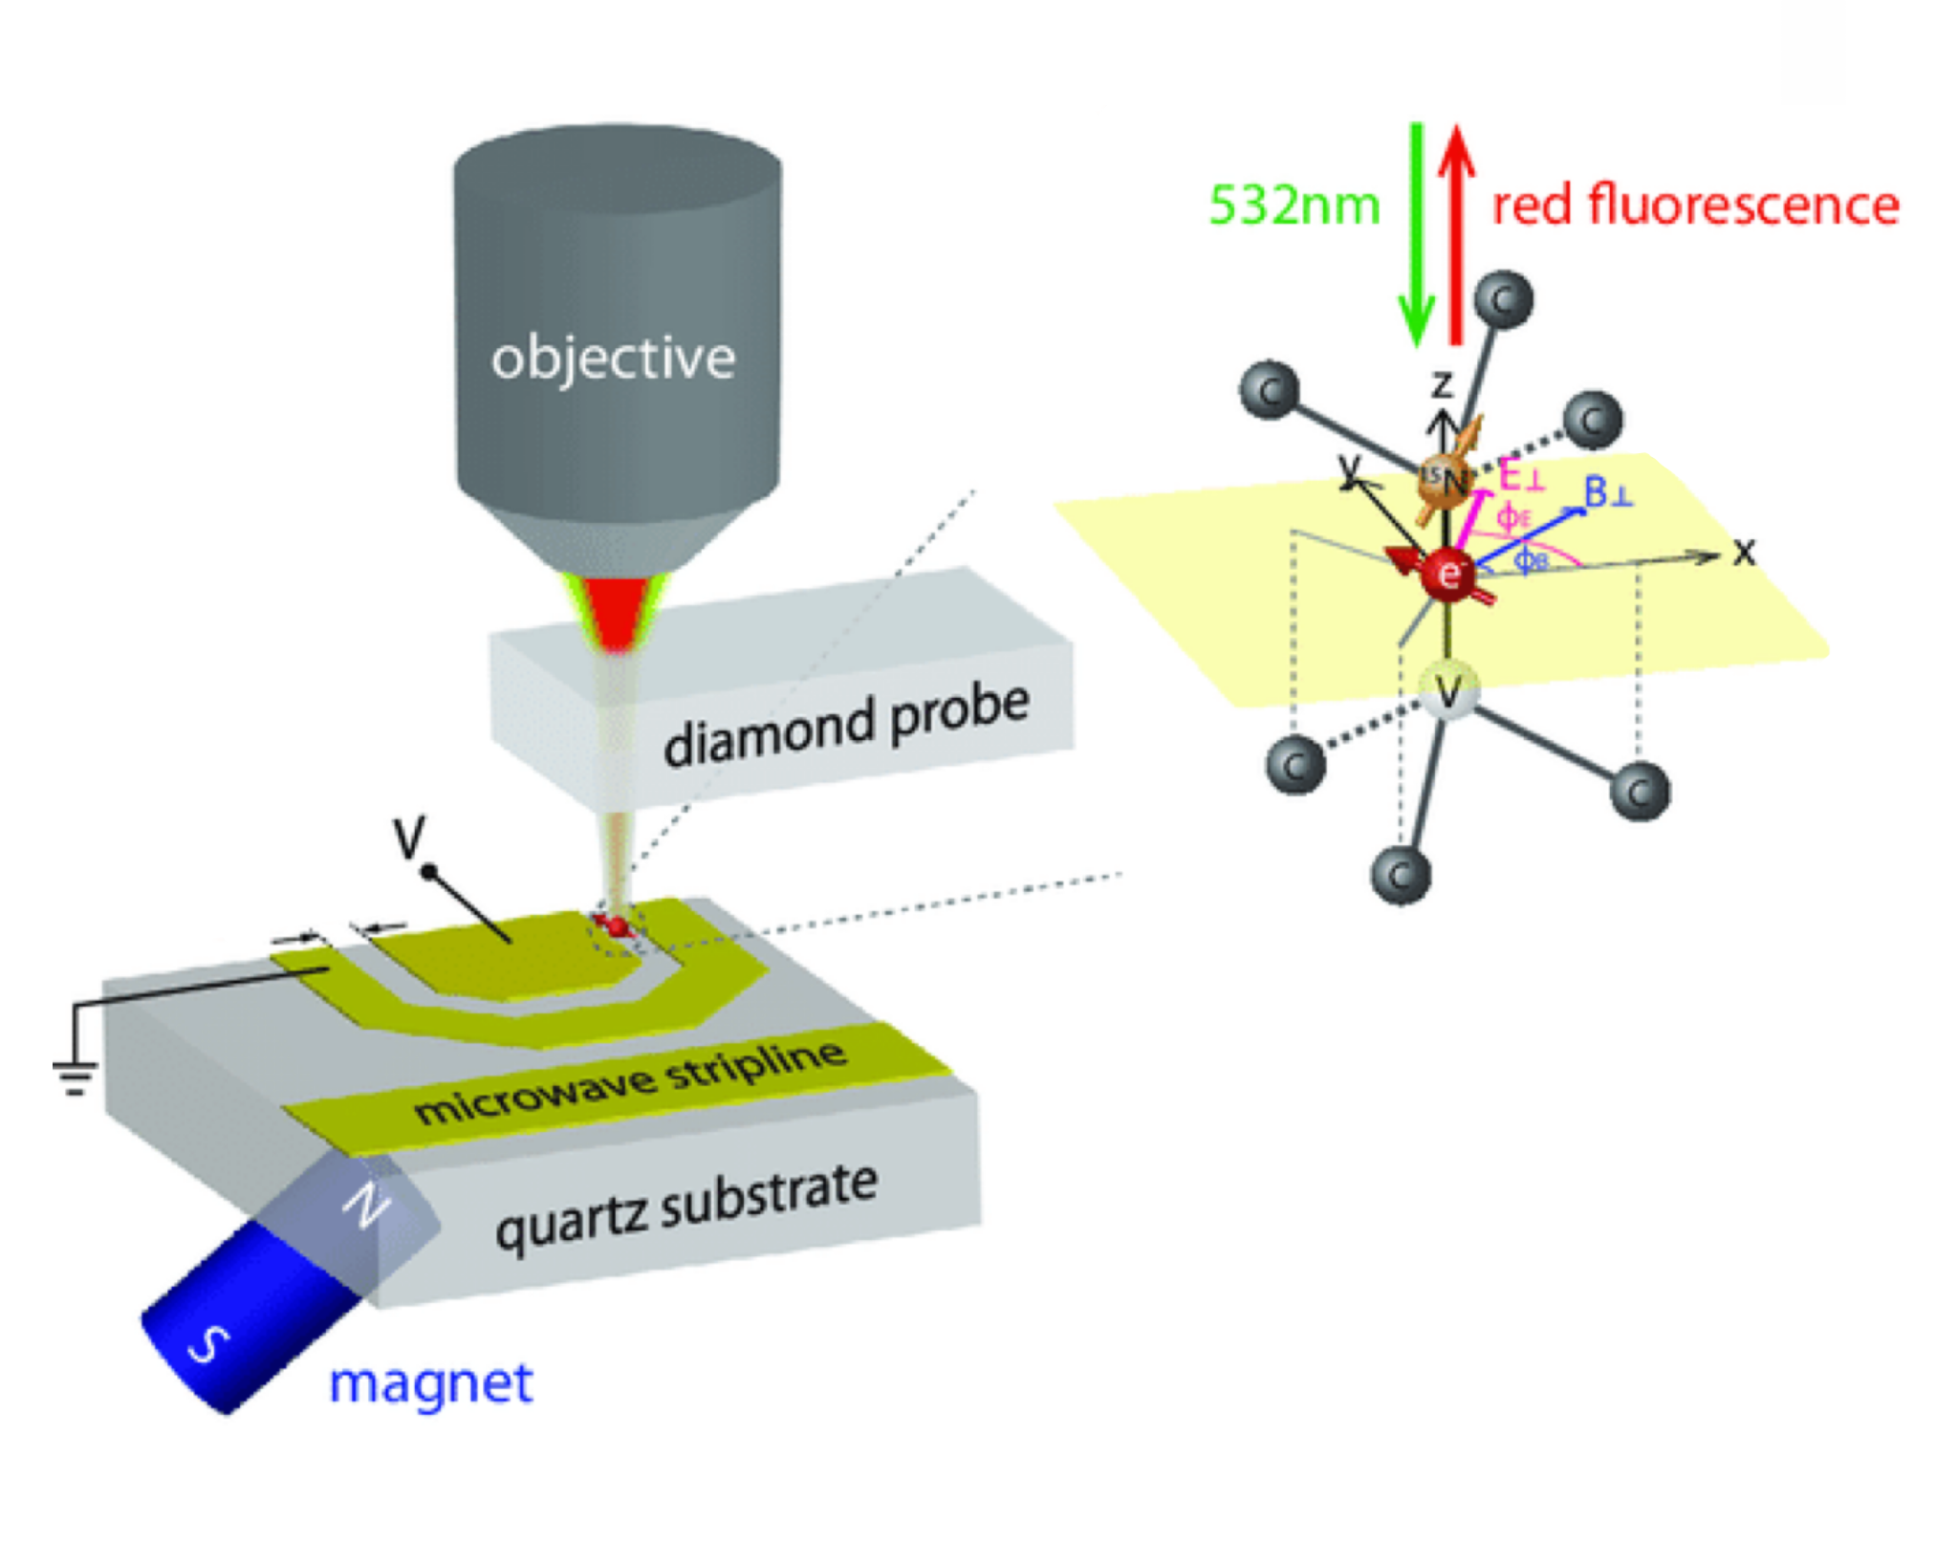

**solid-state qubit** - one proposed mechanism for creating solid-state qubits for future quantum computers uses electromagnetic radiation in the microwave frequency region to interact with [nitrogen-vacancy centers in diamond](https://www.qutube.nl/quantum-computer-12/nv-center-qubits-173) placed in a magnetic field. Readout and control of the nitrogen vacancies are done using electromagnetic radiation in the optical region.  
Image modified from source: Qiu, Z., Hamo, A., Vool, U., Zhou, T. X., & Yacoby, A. (2022), [CC BY-SA 4.0](https://creativecommons.org/licenses/by-sa/4.0/deed.en) (5).

## Guided Inquiry Questions

1. What are common elements to the different apparatuses that utilize magnetic resonance?
2. What are some apparent differences between these MR apparatuses? Why might this be the case?

# 

# How does MR Compare with Related Technologies?

As seen in the previous section, MR is used in a wide variety of technologies. In this section, we will focus on some of the most widely known applications of MR - NMR spectroscopy and magnetic resonance imaging (MRI) - and provide a comparison with other related technologies.

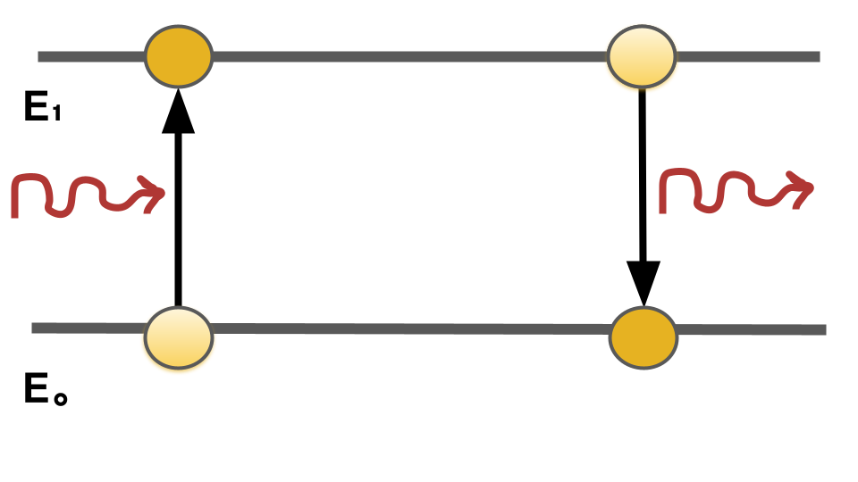

(Left) Light can be absorbed by a quantum particle to move to a higher energy level. (Right) Light can be emitted by a quantum particle to move to a lower energy level.

***REFERENCES:***   
NMR (6, 7, 8);  
Raman (9, 10);  
IR (11, 12);  
UV (13);  
X-ray (14, 15, 16)

## Spectroscopy

Spectroscopy is the study of how electromagnetic radiation is absorbed and emitted by matter and is used in a variety of scientific disciplines for chemical analysis of samples. Electromagnetic radiation is only absorbed or emitted at certain frequencies that match the energy difference between the two quantum states the quantum particle is transitioning between. Different frequencies of light can excite different components of matter including entire molecules, bound electrons, or atomic nuclei.

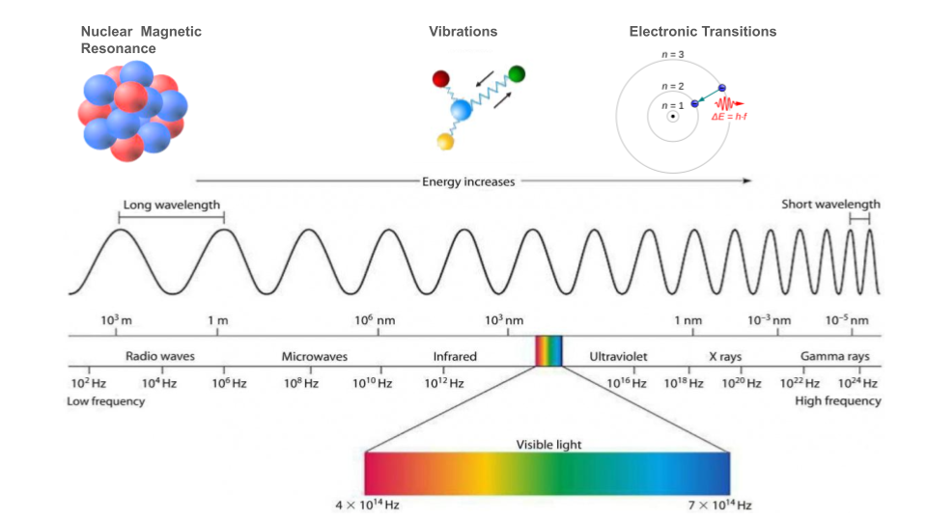

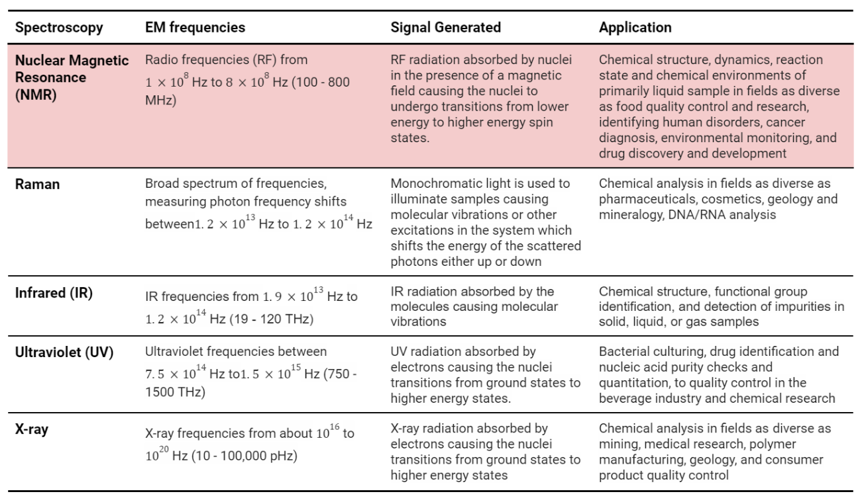

## Imaging

Scientists have developed multiple methods of non-invasive, three-dimensional imaging utilizing the different parts of the electromagnetic spectrum. MRI encodes spatial information into the MR signal to provide a completely unique form of imaging. Below are some figures highlighting and comparing some of these different imaging methods.

***REFERENCES:***   
Image source: J. Andreu-Perez, C. C. Y. Poon, R. D. Merrifield, S. T. C. Wong and G. -Z. Yang (2015), [CC BY-SA 4.0](https://creativecommons.org/licenses/by-sa/4.0/deed.en) (17);  
MRI (18);  
Optical Imaging (19);  
CT Scan (20);  
SPECT (21)

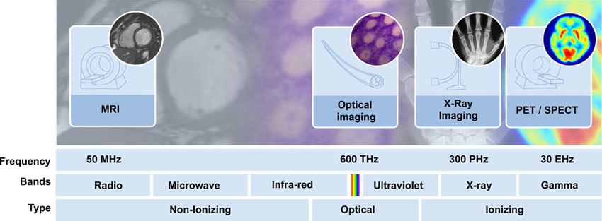

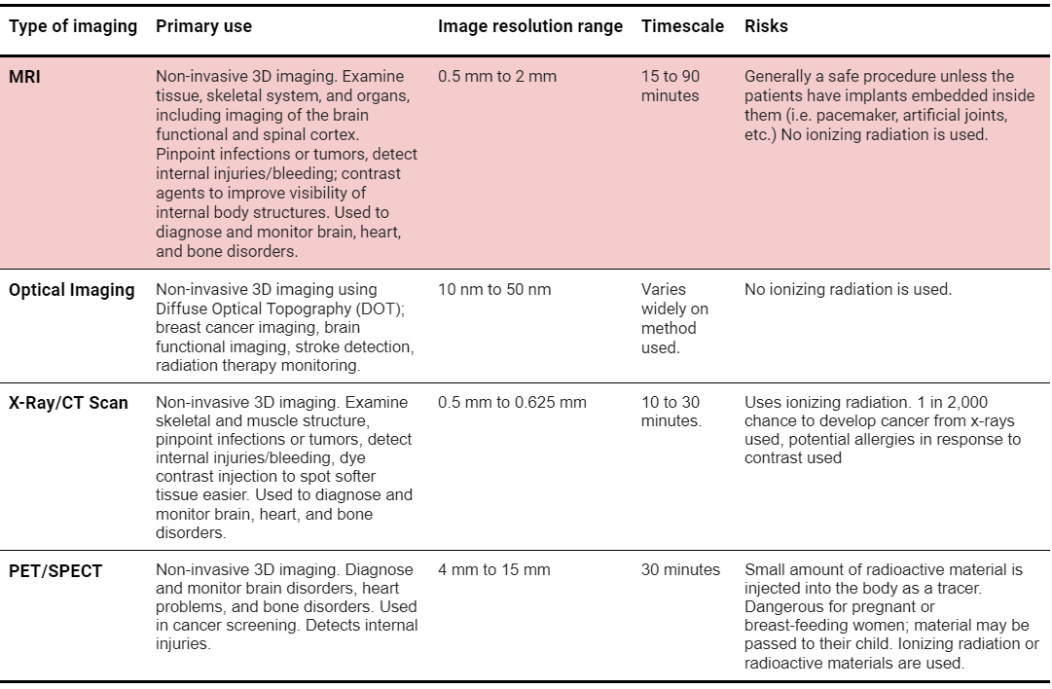

## Guided Inquiry Questions

1. What similarities and differences does NMR spectroscopy have compared with the other types of spectroscopy listed?
2. Why might scientists choose to use NMR spectroscopy instead of other spectroscopy techniques? When might other spectroscopy techniques be more suitable?
3. What similarities and differences does MRI have compared with the other types of imaging modalities listed?
4. Why might scientists choose to use MRI instead of other imaging technologies? When might other imaging techniques be more suitable?

# Reflection Questions

1. Do magnetic resonance techniques provide any more information beyond the other technologies shown here? Any advantages or disadvantages?
2. How might having access to information about the magnetic environment of atoms be useful? What industries could make use of this information? What scientific questions could potentially be explored?
3. Do you think magnetic resonance techniques have passed their prime? Why or why not?
4. What voices are we missing in this history of magnetic resonance? Would this in any way affect its overall impact? Why or why not?

## Cited Sources

1. Boesch, Chris. [“Nobel Prizes for Nuclear Magnetic Resonance: 2003 and Historical Perspectives”](https://onlinelibrary.wiley.com/doi/pdf/10.1002/jmri.20120) *Journal of Magnetic Resonance Imaging* 20:177–179 (2004)
2. <https://www.sigmaaldrich.com/US/en/applications/analytical-chemistry/nuclear-magnetic-resonance> “Sigma Aldrich: Nuclear Magnetic Resonance”
3. <https://commons.wikimedia.org/wiki/File:X-band_CW_EPR_spectrometer_model.png> "File:X-band CW EPR spectrometer model.png"
4. <https://nationalmaglab.org/magnet-academy/read-science-stories/science-simplified/mri-a-guided-tour/> “MRI: A Guided Tour”
5. <https://www.nature.com/articles/s41534-022-00622-3> “Figure 1: Experimental setup and NV center from ‘Nanoscale electric field imaging with an ambient scanning quantum sensor microscope’”
6. <https://chem.libretexts.org/Bookshelves/Organic_Chemistry/Map%3A_Organic_Chemistry_(Wade)/12%3A_Nuclear_Magnetic_Resonance_Spectroscopy/12.01%3A_Theory_of_Nuclear_Magnetic_Resonance_(NMR)> “Theory of Nuclear Magnetic Resonance”
7. <https://chem.libretexts.org/Bookshelves/Physical_and_Theoretical_Chemistry_Textbook_Maps/Quantitative_NMR_(Larive_and_Korir)/01%3A_Basic_NMR_Theory/1.02%3A_How_does_absorption_of_energy_generate_an_NMR_spectrum> “How does absorption of energy generate NMR spectrum”
8. <https://www.acs.org/content/acs/en/education/whatischemistry/landmarks/mri.html> “NMR and MRI: Applications in Chemistry and Medicine”
9. <https://www.sas.upenn.edu/~crulli/RamanBasics.html> “Raman Spectroscopy”
10. <https://www.horiba.com/int/scientific/technologies/raman-imaging-and-spectroscopy/application-field/> “Most common uses of Raman Spectroscopy”
11. <https://www.platypustech.com/5-different-types-of-spectroscopy> “5 Different Types of Spectroscopy”
12. <https://www.amrutpharm.co.in/doc/ppt/2019-20/ir.pdf> “Instruments of Infared Spectroscopy”
13. <https://www.technologynetworks.com/analysis/articles/uv-vis-spectroscopy-principle-strengths-and-limitations-and-applications-349865> “UV spectroscopy”
14. <https://www.labcompare.com/Spectroscopy/177-X-Ray-Spectrometer-X-Ray-Diffraction/> “X ray spectrometer”
15. <https://www.britannica.com/science/X-ray> “X-ray Definition”
16. <https://www.nibib.nih.gov/science-education/science-topics/x-rays> “Xrays”
17. <https://ieeexplore.ieee.org/document/7154395> “Figure 8: Different imaging modalities across the electromagnetic spectrum”
18. <https://www.nature.com/articles/d41586-018-07182-7> “Worlds strongest MRI”
19. <https://www.nibib.nih.gov/science-education/science-topics/optical-imaging> “Optical Imaging”
20. <https://www.ncbi.nlm.nih.gov/pmc/articles/PMC4752333/> “What are the basic concepts of temporal, contrast, and spatial resolution in cardiac CT?”
21. <https://www.mayoclinic.org/tests-procedures/spect-scan/about/pac-20384925> “Spect Scan”